Travelling Salesman Problem (TSP)
Aim
To find the shortest possible route that visits every city exactly once and returns to the starting city.
Objectives
- To understand optimization problems.
- To find the minimum cost path.
- To visit all cities exactly once.
- To implement a brute-force solution.
Algorithm
- Start.
- Define the distance matrix.
- Select the starting city.
- Generate all possible city permutations.
- Calculate the total cost for each route.
- Find the minimum cost route.
- Display the optimal path and cost.
- Stop.
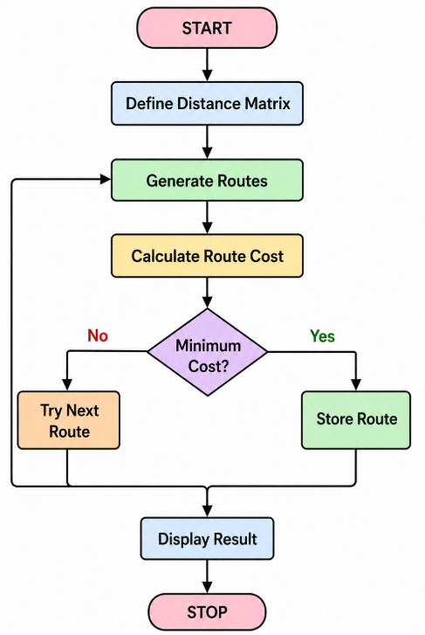

PROGRAM

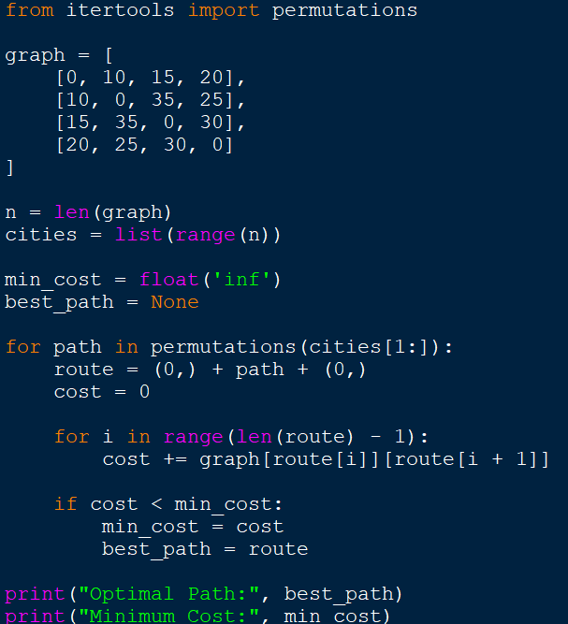

OUTPUT
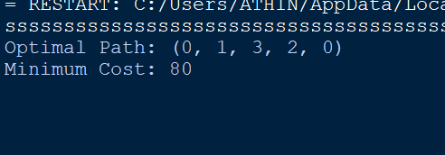

Result
The Travelling Salesman Problem was successfully solved, and the minimum-cost route visiting all cities exactly once was obtained.

